**Panton Practice Newsletter**

**Produced by the Patient Participation Group (PPG)**

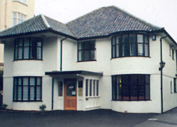    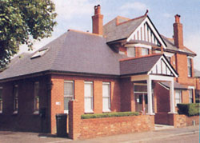

**SPRING 2017 ISSUE**

**SURGERY NEWS!**



Online you can find:

Patient Registration

Repeat prescriptions

Book an appointment

Online services to register for ‘Systmonline’

Contact details/next of kin

Useful numbers

Accountable GP

Joining the PPG

For Carers – help information and support

Many other key information titles

There is also a Live Well link which covers:

* Child health
* Men’s Health
* Women’s Health
* Featured Topics – group topics
* Special reports
* Common health questions
* Conditions A to Z
* Live Well topics A-Z

**The surgery is looking to bring in other skilled professionals like Nurse Practitioners or Emergency Care Practitioners to work in conjunction with the doctors, to improve the service we offer our patients.**

**We officially welcome Karen our Health Care Assistant to our nursing team, who apart from other duties, runs a walking group on Monday, Wednesday and Friday mornings. (Please see over page for details)**

**NOTICE TO PATIENTS**

**We would like to inform our patients that Dr McKenna will be retiring from the practice on Friday 31st March 2017.**

**Dr McKenna has been with the practice for 24 years and I’m sure all of our patients would like to wish her a happy and enjoyable retirement.**



**All of Dr McKenna’s registered patients will be looked after by Dr Sawyer, Dr King, Dr Marshall and Dr Graham until a new GP has been recruited.**

**CONTACT**

**INFORMATION**





14 Gervis Road  
 BOURNEMOUTH BH1 3EG  
 Tel: 01202 411700  
 Fax: 01202 411709



20 St Leonard's Road,

Charminster,   
 BOURNEMOUTH BH8 8QN  
 Tel: 01202 411700  
 Fax: 01202 541249

Web Site:

www.thepantonpractice.co.uk

www.thepantonpractice.co.uk

**The surgery now has a Facebook page up and running, this is for advertising, news and events related to the practice along with any mandatory training dates when we will be closed.**

**https://www.facebook.com/ThePantonPractice/**



**Panton Practice Walking Group**

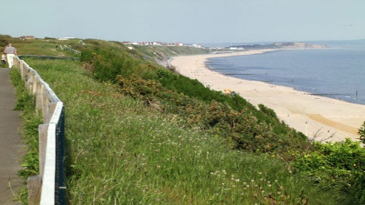

**Karen the Health Care Assistant, runs a walking group at Gervis Road Surgery.**

**It is a 30 minute gentle walk along the seafront with lovely views, on Monday, Wednesday and Friday morning from 10am to 10.30 am. Meet at the surgery at 9.45 am.**

**Do bring a friend, if you’d like to! You can even bring your dog! Ask a receptionist if you have any questions, otherwise just turn up. No booking required.**

**National Health Awareness Months**

**National Bowel Cancer Awareness Month**

**April 2017**

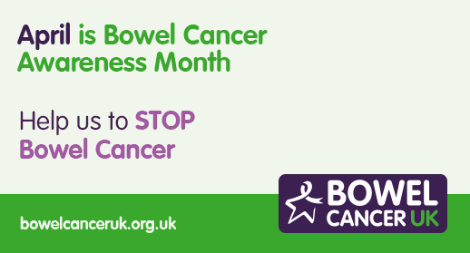

April is National Bowel Cancer Awareness Month which raises awareness of bowel cancer screening to improve early diagnosis of the disease. Bowel cancer is the UK’s second biggest cancer killer but it is treatable and curable especially if diagnosed early. If you are registered with a GP and aged 60-74 you will receive a free NHS bowel cancer screening test in the post every two years. You can find some leaflets and booklets on bowel cancer at this surgery in the foyer. <http://www.bowelcanceruk.org.uk>

**National Walking Month**

**May 2017**

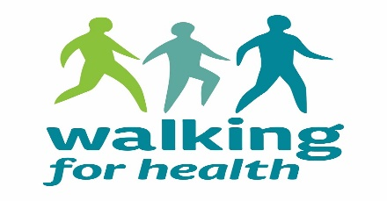

May is National Walking Month and Living Streets which is the national charity that works to create safe, attractive and enjoyable streets. They will be encouraging people to walk with their successful annual initiatives - Walk to Work Week and Walk to School Week. Through these events, they hope to show children and adults how easy, enjoyable and rewarding walking is and how it can lead to real changes in people's habits and lifestyles.

<http://www.livingstreets.org.uk>