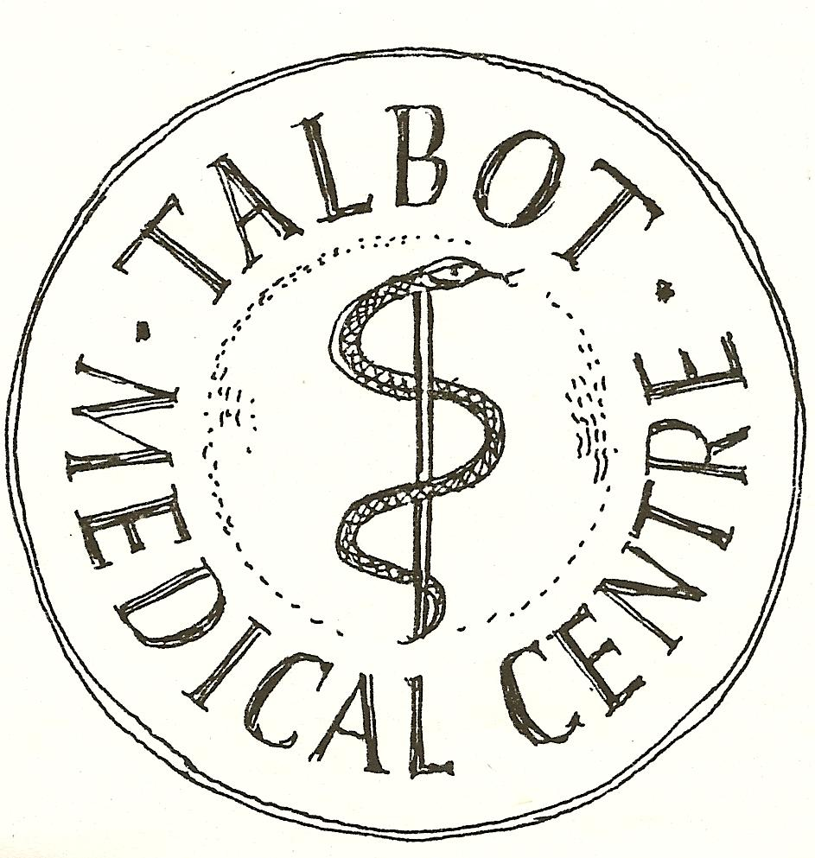

THE PANTON PRACTICE
Sharing Your Health Record Opt Out Form
Sharing Your Health Record for the Purposes of Your Direct Care
As a default, we will set your record as available to share out in both in SystmOne and the Summary Care Record.

If your choice is to Opt out of ‘Sharing out’ from your GP record (XaQVo) please tick here
(this will mean that if you attend another healthcare provider and give consent for them to access your GP records, these will not be available)
Your Summary Care Record (SCR)
If your choice is to opt out of having a Summary Care Record (XaXj6), please tick here

Data sharing for Research (Not for direct care)
If your choice is to opt out of data sharing for Research:

I do not wish identifiable data about me to leave the practice.(XaaVL)
I do not wish data about me to be shared by HSCIC . (XaZ89)

Signature
Signature | ………………………………………………………………………………………………………..
 | Signed on behalf of patient
Patient Name | …………………………………………………………………………………………….. dob: …………………………..
Date

