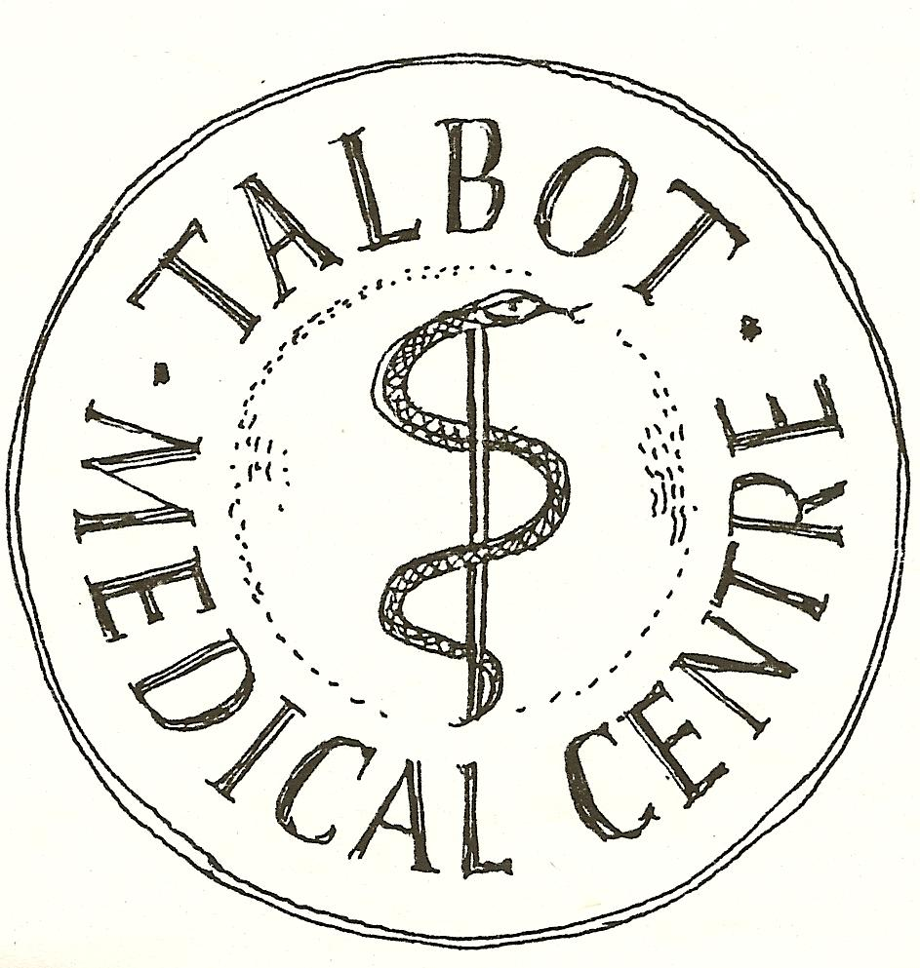

THE PANTON PRACTICE
How We Use Your Health Records

This leaflet explains:

- Why the NHS collects information about you and how it is used.

- Who we may share information with.

- Your right to see your health records and how we keep your records confidential.

Why we collect information about you:
In the National Health Service we aim to provide you with the highest quality of health care. To do this we must keep records about you which contain information recorded by health workers who have been involved in your care.

What records about you do we keep?
- Basic details about you such as address, date of birth, next of kin;
- Contact we have had with you such as clinical visits;
- Notes and reports about your health;
- Details and records about your treatment and care;
- Hospital letters;
- Results of x-rays, laboratory tests, etc;
- Relevant information from people who care for you and know you well such as health professionals and relatives

It is good practice for people in the NHS who provide care to:
- Discuss and agree with you what they are going to record about you and
- if you ask, show you what they have recorded about you

How we keep your records confidential
- Everyone working for the NHS has a legal duty to keep information about you confidential and this practice retains your information securely;
- We will only ask for and keep information that is necessary. We will keep it as accurate and up to-date as possible. We will explain the need for any information we ask for if you are not sure why it is needed;
- To help us protect your confidentiality it is important to inform us about any relevant changes that we should know about. This would include such things as change of personal circumstance, change of address and phone numbers;
- All persons in the practice (not already covered by a professional confidentiality code) have a confidentiality clause within the Contract of Employment that explicitly makes clear their duties in relation to personal health information and the consequences of breaching that duty.
- Access to patient records by staff other than clinical staff is regulated to ensure that they are used only to the extent necessary to enable tasks to be performed for the proper functioning of the practice. In this regards, patients should understand that practice staff may have access to their records for:
  - Identifying and printing repeat prescriptions for patients. These are then reviewed and signed by the GP.
  - Generating a medical certificate for the patient. This is then checked and signed by the GP.
  - Typing referral letters to hospital consultants or allied health professionals such as physiotherapists, occupational therapists, psychologists and dieticians.
  - Opening letters from hospitals and consultants. The letters could be appended to a patient’s paper file or scanned into their electronic patient record.
  - (This list is not exhaustive).

We have a duty to
- Maintain full and accurate records of the care we provide to you
- Keep records about you confidential and secure
- Provide information in a format that is accessible to you (e.g. large type if you are partially sighted)

What information about you do we share?
The reason we share your information is solely for the purpose of your direct care. There are currently three ways that this can be processed.

Summary Care Record (SCR)
A Summary Care Record will, in its basic form, contain important information about any medicines you are taking, allergies you suffer from and any bad reactions to medicines that you have had.

Giving healthcare staff access to this information can prevent mistakes being made when caring for you in an emergency or when your GP practice is closed. Your Summary Care Record will also include data to uniquely identify you.

You can also ask your practice to include additional information such as current conditions on your SCR. It is very straight forward to add but we can only do this with your express permission. Patients who may benefit from sharing additional information are those with complex medical histories or more frail patients who are at risk of being admitted to hospital suddenly.

GP clinical system: The Enhanced Data Sharing Model (EDSM) in SystmOne.
From time to time it is helpful for us to be able to share information about your health and care requirements with other health organisations. Work has been ongoing to improve the way that medical records are made available to clinicians involved in your treatment. As a result of this work we are now able to share clinical information between health professionals including other GP practices, child health services, community health services, hospitals, out of hours, palliative care providers and similar.

Sharing of information in this way is designed to ensure that the healthcare professional looking after you has the most relevant information to enable them to provide you with the most appropriate care. The type of information shared includes a summary of current problems, current medication, allergies, recent tests, diagnosis, procedures, investigations, risks and warnings - all information is currently held in your GP system record (unless marked as private).

Whenever a clinician from another healthcare organisation wishes to view your record they should seek your permission before doing so: if you say "no" they will not be able to see any information. From May 2018, we will automatically set up the sharing facility to allow your information to be shared (this is called Sharing Out). However, if you do not wish us to share your information in this way please let us know and we will ensure that your information is not shared. Please complete the Data Sharing Opt Out form at the back of this leaflet and return it to Reception.
If you see a healthcare professional outside your local geographic area (who also uses SystmOne) and you agree that they can have access to your medical records, you will now be asked to provide additional security details, in the form of a verification code which is sent to you either as a text, email or via your SystmOnline account. It is therefore important to ensure that we always have your current contact details. When you receive care close to home, you will not usually be asked to give a verification code.

There is a separate leaflet about SystmOnline which explains how to register for an account and the benefits of on-line services e.g. the ability to book GP appointments, order repeat prescriptions and view your medical record.

Sharing information helps clinicians to make decisions based upon wider knowledge of you and also helps to reduce the number of times you or your family members are asked the same question. In short, it assists clinicians to provide more "joined up care". An audit log is maintained showing who has accessed your record, and when, and you are entitled to request a copy of that log.

Dorset Care Record (DCR) The Practice has not signed up to this data sharing option
Health and social care organisations in Dorset hold different sets of records about you and not every organisation uses SystmOne. The Dorset Care Record is a confidential computer record that will join up all these different records to create one complete and up-to-date record. Over time this will help improve the care you receive. Information will be taken from GP Practices, hospitals within Dorset, Dorset Healthcare University NHS Foundation Trust, Dorset CCG, South West Ambulance Trust and the councils within Dorset. Records will only be viewed by authorised staff who are directly involved in your care.
For more detailed information visit the Dorset Care Record (DCR) website. If you do not wish your information to be shared in this way, you will need to opt out. To do this, fill in a form (available from the Opt Out page of the DCR website or via a leaflet in Reception) and send it to the Privacy Officer at Dorset Care Record.

Other Agencies
The NHS may not be the only government service to provide you with the care you need. It may be necessary for us to provide information to other agencies directly involved in your care. Under these circumstances we will seek your consent before information is shared.

We may request your specific consent to use personal information in research projects or other non-medical aspects of treatment. If you do not wish your information/medical records to be accessed for such a purpose, please inform a member of staff.

Can you ask for your information not to be shared?
You can ask for any information and/or consultation to be marked as private. This means that viewing this particular information and/or consultation is restricted to staff (clinical and non-clinical) in this Practice. It is your responsibility to tell us if there is any information that you wish to be marked as private.

Can I change my mind?
Yes, you can always change your mind and amend who you give consent to see your records. For instance, you can decline to share your records out from the surgery, but if you build up a relationship with the physiotherapist who was treating you and they ask you if they could look at an x-ray report, you could give your consent at that point for them to view your records.

You will be referred back to us to change your preference, so the physio treating you should - with your permission - be able to see your records by the time of your next appointment.

If I decline - what happens in an emergency?
In the event of a medical emergency, for instance if you were taken unconscious to A+E, and the clinician treating you feels it is important to be able to see your medical records, he will be able to override any consents set.
However, the doctor has to give a written reason for doing so. Where this happens an audit is undertaken by the local Caldicott Guardian (the person with overall responsibility for Data Protection compliance).

If you would prefer not to have your record shared in any of these ways, please complete the Data Sharing Opt Out Form at the rear of this leaflet and return it to Reception. The form is also available on our website.

Access to your records?
The Data Protection Act 2018 gives every living person, or an authorised representative, the right to apply for access to their health records. You have a right to ask for a copy of records held about you. From 25th May, 2018 there will be no charge, unless the request is excessive or repetitive and we are required to respond within one month.

If you think anything is factually inaccurate or incorrect, please inform your GP so an explanatory comment can be added to your record.

Can I access my medical records online?
Yes, you can via SystmOnline, but you will need to be registered with SystmOne on-line first, which can be done by bringing in ID to the practice and asking the Receptionist to print out a user name and password on proof of ID.

Can anyone else see my medical records?
No-one other than the people involved in your medical care are able to see your medical records, unless you give your written consent for this to happen; e.g. we get requests from insurance companies to either have copies of medical records or excerpts from patients' medical records. This requires your signed consent as the information has not been requested for the purpose of treating or caring for you.

Occasionally, we are asked for information from the records for legal reasons; again, this has to be done with your written consent, or in very exceptional cases, by court order.

Data sharing for Research (Not for direct care)

NHS England aims to link information from all the different places where you receive care, such as hospital, community service and us your GP Surgery. This will allow them to compare the care you received in one area against the care you received in another.

Information will be held in a secure environment called the Health and Social Care Information Centre (HSCIC). The role of the HSCIC is to ensure that high quality data is used appropriately to improve patient care. The HSCIC has legal powers to collect and analyze data from all providers of NHS care. They are committed, and legally bound, to the very highest standards of privacy and confidentiality to ensure that your confidential information is protected at all times.

This data can also be used, with permission from NHS England, for research purposes.
- You can object to information containing data that identifies you from leaving the Practice. This will prevent identifiable information held in your record from being sent to the HSCIC secure environment. It will also prevent those who have gained special legal approval from using your health information for research.
- You can also object to any information containing data that identifies you from leaving the HSCIC secure environment. This includes information from all places you receive NHS care, such as hospitals. If you object, confidential information will not leave the HSCIC and will not be used, except in very rare circumstances for example in the event of a public health emergency.

For more information visit: www.england.nhs.uk/caredata

The law requires Doctors to provide some very limited information about certain things. The law says, for example, that Doctors must provide information to local authorities about some infectious diseases, e.g. if you had food poisoning. Very rarely, Doctors may be required to disclose information in order to detect a serious crime. Likewise, a court order can require Doctors to disclose certain information during a court case.

If you would like this letter or information in an alternative format, for example large print or easy read, or if you need help communicating with us, for example because you use British Sign Language, please let us know. If you have any questions, please speak to a receptionist. If necessary, they will arrange for another member of the team to give you a call.
THE PANTON PRACTICE
Sharing Your Health Record Opt Out Form
Sharing Your Health Record for the Purposes of Your Direct Care
As a default, we will set your record as available to share out in both in SystmOne and the Summary Care Record.

If your choice is to Opt out of ‘Sharing out’ from your GP record (XaQVo) please tick here
(this will mean that if you attend another healthcare provider and give consent for them to access your GP records, these will not be available)
Your Summary Care Record (SCR)
If your choice is to opt out of having a Summary Care Record (XaXj6), please tick here

Data sharing for Research (Not for direct care)
If your choice is to opt out of data sharing for Research:

I do not wish identifiable data about me to leave the practice.(XaaVL)
I do not wish data about me to be shared by HSCIC . (XaZ89)

Signature
Signature | ………………………………………………………………………………………………………..
 | Signed on behalf of patient
Patient Name | …………………………………………………………………………………………….. dob: …………………………..
Date

