**Panton Practice Newsletter**

**Produced by the Patient Participation Group (PPG)**



 

**SUMMER 2017 ISSUE**

**\*\*\*\* SURGERY NEWS! \*\*\*\***

**Nurse Practitioners** – **You may have seen this advertised at both surgeries and on our Facebook page.  The Nurse Practitioners will start during June. We have Justine starting on Monday 5th June and Suzanne starting on Wednesday 21st June. The doctors will support them during their first month. The Nurse Practitioner appointments will be held at Gervis Road Surgery. More routine appointments will be available, estimated at 6 appointments per GP per day depending on how many doctors are in the surgery that day.**



MISSED

APPOINTMENTS

If you are unable to make your appointment, please let the surgery know by telephone (01202 411700) or text as soon as possible. Please help us to use our clinical time effectively. We have, on average over 30 non-urgent routine appointments lost each week as patients either forget or do not inform us in time. This is around 30 - 40 appointments of a doctor’s time each week, sometimes more and costs time and money.

**New Text Cancellation Service**  **MJOG**

This is a very useful application for patients and the surgery in providing reminders for appointments at the Practice.  It also gives patients the opportunity to cancel in advance by replying to the received text message so avoiding missing appointments, having Did Not Arrive notification on your record and ensuring that appointments are not lost to other patients.

**Please let us know if you change your mobile number**

**CONTACT**

**INFORMATION**



 **NOTICE TO PATIENTS**

**Mandatory Practice Training in June**

**The surgery will be closed for training purposes on:**

**Thursday 15th June between 13.30pm and 16.30pm**

**If you require medical attention during this time and cannot wait for the surgery to re-open, please telephone the NHS 111 service.**

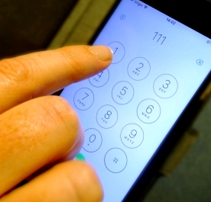



14 Gervis Road  
 BOURNEMOUTH BH1 3EG  
 Tel: 01202 411700  
 Fax: 01202 411709



20 St Leonard's Road,

Charminster,   
 BOURNEMOUTH BH8 8QN  
 Tel: 01202 411700  
 Fax: 01202 541249

Web Site:

www.thepantonpractice.co.uk

**The surgery now has a Facebook page up and running, this is for advertising, news and events related to the practice along with any mandatory training dates when we will be closed.**

**https://www.facebook.com/ThePantonPractice/**



**Panton Practice Walking Group**

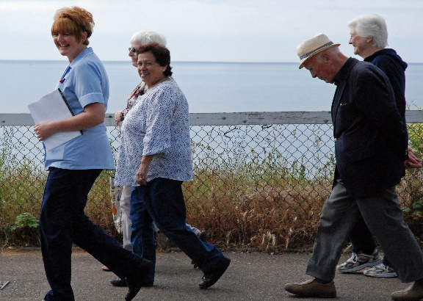

**HCA Karen with some of her Wednesday walkers in May**

**Karen the Health Care Assistant runs a walking group at Gervis Road Surgery.**

**It is a 30 minute gentle walk along the seafront with lovely views, on Monday, Wednesday and Friday morning from**

**10am to 10.30 am. Meet at the surgery at 9.45 am. Do bring a friend, if you’d like to! You can even bring your dog!**

**Ask a receptionist if you have any questions, otherwise just turn up. No booking required.**

We all like being in the sun but getting sunburn harms your skin and this doesn't just happen on holiday – you can burn in the UK, even when it's cloudy.

There is no safe or healthy way to get a tan. A tan doesn't protect your skin from the sun's harmful effects.

Aim to strike a balance between protecting yourself from the sun and getting enough vitamin D from sunlight.

Most people can make enough vitamin D from being out in the sun daily for short periods with their forearms, hands or lower legs uncovered and from late March or early April to the end of September. But you should be careful not to burn in the sun, take care to cover up, or protect your skin with sunscreen, before your skin starts to turn red or burn.

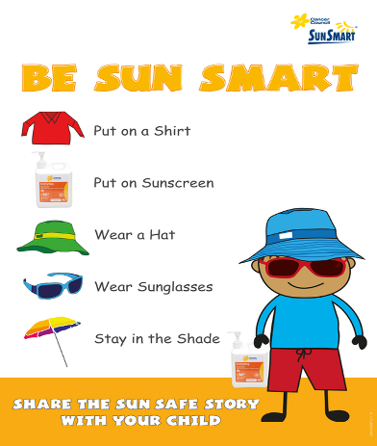

**National Health Awareness Month**

**Men’s Health Week will run from 12th – 18th June**

This is led by the Men’s Health Forum at [www.menshealthforum.org.uk](http://www.menshealthforum.org.uk) The purpose of Men’s Health Week is to raise awareness of preventable health issues and encourage men and boys to seek professional advice for health related problems.

This year, it will be focusing on belly fat. Why? Because it's the type of fat that's bad for your health and men are more likely to have it.

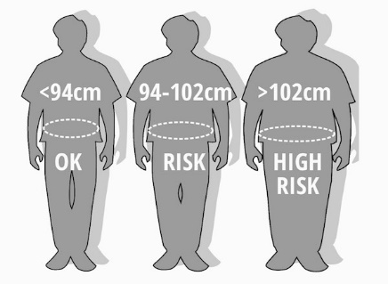It's a problem because this type of fat lurks not just beneath the surface but also gets down deep and surrounds the vital organs. Regardless of your overall weight, a large amount of this fat increases your risk of:

* Cardiovascular disease
* Insulin resistance and type 2 diabetes
* 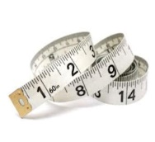Colorectal cancer
* Sleep apnoea
* Premature death from any cause
* High blood pressure

So you need to get those tape measures out! <37 inch 37 - 40 inch >40 inch